Blue 蓝色 = guide by Omer and extra information 的指南和额外信息

Orange 橙色 = Example 例子= student can write like this (Guide by omer). But when you write real report use black font.

学生可以这样写(奥默的指南)。但是当你写真正的报告时，使用黑色字体。

*Black* 黑色 *= General guide By Australian teacher* 一般指南澳大利亚老师

Red 红色 = Very important guide by *Australian teacher*

澳大利亚老师非常重要的指导

**[Your REPORT TITLE]**

**Evaluative Report**

By [Your Name]

Table of Contents

Introduction 3

Application or website evaluated 3

Evaluation 3

User Interface & Interactivity 3

User Experience 3

Discussion 3

Conclusion 3

References 4

Appendix 4

Before I explained what the introduction section should have. First need to understand two terms User interface (UI), and User experience (UX).

User interface (UI) = 软件 Ideally, when programmer design a website, he should care various design elements [consistency, aesthics, Visual/Graphical elements, text, navigation, Input Controls, feedback, and background] in view of best practices. It means many people already develop some famous standards (best practices) when designing a website or app. You can check also online. When a programmer design a website, he keep in mind the following best practices (of previous people or industry standard) focus on following areas

在我解释介绍部分应该包含什么之前。首先需要理解两个术语:用户界面(UI)和用户体验(UX)。理想情况下，当程序员设计一个网站时，他应该考虑各种设计元素(一致性、美学、视觉/图形元素、文本、导航、输入控制、反馈和背景)，以获得最佳实践。这意味着许多人在设计网站或应用程序时已经制定了一些著名的标准(最佳实践)。你也可以在网上查看。当一个程序员设计一个网站时，他会牢记以下最佳实践(前人的或行业标准)，重点关注以下领域

**UI 软件 (Best Practices)**

* Be Consistent in Your UI Elements 保持UI元素的一致性
* Know Your Target Audience 了解你的目标受众
* Conduct Thorough User Research 进行彻底的用户研究
* Layout Matters But Keep It Simple 布局很重要，但要保持简单
* Leverage Available Design Patterns First Before Creating Your Own
* 在创建自己的设计模式之前，首先利用可用的设计模式
* Prioritize Functionality Over Aesthetics 优先考虑功能而不是外观
* Do Not Overlook Product Content 不要忽视产品内容
* Do Not Forget User Testing 不要忘记用户测试

On other hand, User experience (UX) is Personal (男生，女生， 感觉), how a man feels when he use a website or online story. It explains how a website care about people feeling. Most people agree on some principles (industry standard) when desining a user experience. You can search online these principles which say following.

另一方面，用户体验(UX)是个人的体验，一个人在使用网站或网络故事时的感受。它解释了一个网站如何关心人们的感受。大多数人在设计用户体验时都认同一些原则(行业标准)。你可以在网上搜索以下这些原则。

**User experience (UX) Principles 用户体验(UX)原则**

* **User centric** (focus on user needs) Putting your user, their pain points, wants and needs in the center of your UX design process.

以用户为中心(关注用户需求)把你的用户，他们的痛点，欲望和需求放在你的UX设计过程的中心。

* **Hierarchy** It helps to draw users attention to the most important elements on the website and optimizes navigation. Hierarchy in design is mostly emphasized with the use of color, size, contrast and other elements.

层次结构 它有助于将用户的注意力吸引到网站上最重要的元素上，并优化导航。设计中的层次结构主要是通过使用颜色、大小、对比和其他元素来强调的。

* **Usability** Good usability assures that users are able to easily perform specific tasks with your product. Usability testing is an ultimate way to spot and eliminate roadblocks, confusions and significant UX issues.

可用性 良好的可用性确保用户能够轻松地使用您的产品执行特定的任务。可用性测试是发现和消除障碍、困惑和重大用户体验问题的最终方法。

* **Consistency** Consistency is an important element both in UI and UX design. In the UI design process it’s all about visual consistency. As a designer, you need to make sure that your branding is consistent across all the different pages and products. Using the same fonts, colors, layouts and brand elements is essential for a clear brand image. Consistency in terms of branding is achieved by creating and following design systems.

一致性 一致性在UI和UX设计中都是一个重要元素。在UI设计过程中，最重要的是视觉一致性。作为一名设计师，你需要确保你的品牌在所有不同的页面和产品中是一致的。使用相同的字体、颜色、布局和品牌元素对于清晰的品牌形象至关重要。品牌的一致性是通过创建和遵循设计系统来实现的。

* **Accessibility** Making your product accessible means designing it to be usable for as many people as possible. This includes people with disabilities, visual, auditory, cognitive and other impairments.

可访问性 让你的产品具有可访问性意味着你要设计的产品能够被尽可能多的人使用。这包括有视觉、听觉、认知和其他障碍的残疾人。

* **Context** Personalization and adapting to specific contexts in which users interact with your product is key to providing exceptional user experience. Conducting user research can help you find out when and where users might need your product, as well as how they are going to be using it.

上下文 个性化和适应用户与产品交互的特定环境是提供卓越用户体验的关键。进行用户研究可以帮助您发现用户何时何地可能需要您的产品，以及他们将如何使用您的产品。

Technically UI best practices and UX principles has the same concept. Only difference is that. UI use same concepts to design a software or online story. And UX use same concepts to consider the feeling of user, who would use that software. Lets come back to how to write an introduction.

从技术上讲，UI最佳实践和UX原则具有相同的概念。唯一的区别是。UI使用相同的概念来设计软件或在线故事。用户体验使用相同的概念来考虑用户的感受，谁会使用该软件。让我们回到如何写介绍。

# **1.0 Introduction**

***[A short description of the report should go here such as goal, purpose. This could also include a background e.g. why you chose the eBook or online story, what inspired you, etc.***

**报告的简短描述应该放在这里，比如目标，目的。这也可以包括背景，例如为什么你选择电子书或在线故事，是什么激励了你，等等。**

**What mean by Goal/purpose?**

**Example (student can write like this, you can follow the concept but use your idea)**

**示例(学生可以这样写，你可以遵循概念，但使用你的想法)**

**This report evaluates an eBook or online story [XXXXXXXXX] by assess its user experience and user interface based on some design elements*. These elements includes consistency, aesthics, Visual/Graphical elements, text, navigation, Input Controls, feedback, and background. Accordingly, various features** for each design element was asses for effective communication. Later these design elements are discussed against UI best Practices and UX principles to assess how these design elements resembles the industry standards for web design pattern.**

该报告通过基于一些设计元素*评估其用户体验和用户界面来评估电子书或在线故事[XXXXXXXXX]。这些元素包括一致性、美学、视觉/图形元素、文本、导航、输入控制、反馈和背景。因此，每个设计元素的各种特征**都被评估为有效的沟通。稍后，我们将根据UI最佳实践和UX原则讨论这些设计元素，以评估这些设计元素与web设计模式的行业标准的相似程度。

**Background (What inspire you). What this online story aim to tell. You can explain the whole story in 10-30 words. You should try to be very short. How this story feels to you.**

**This eBook or online story inspired me because ……….**

## 

## **Some general guide for introduction 一些一般的介绍指南**

## **An ebook, app, online, can be described in term of how its User Interface & Interactivity is designed concerning following seven design elements (in reality, it can be more than seven design elements). Each design element can be view in term of various features. These design elements should be carefully consider when a programmer design a web page for better User Interface & Interactivity.**

**电子书、应用程序、在线应用程序的用户界面和交互性设计可以通过以下七个设计元素来描述(实际上，它可以是七个以上的设计元素)。每个设计元素都可以用不同的特征来看待。当程序员为了更好的用户界面和交互性而设计网页时，应该仔细考虑这些设计元素。**

1. ***Consistency***: in layouts, navigation, use of design patterns (for mobile and PC if known)

一致性:布局、导航、设计模式的使用(如果已知，适用于手机和PC)

1. ***Aesthetics***: Colour, balance, white space 美学:色彩、平衡、留白
2. ***Visual/Graphical* elements**: icons, images, containers e.g. group boxes, accordions, tab controls.

视觉/图形元素:图标，图像，容器，例如组框，手风琴，选项卡控件。

1. ***Text***: font, colour of on-screen text, tooltips, notifications, message boxes, popups

文本:字体，屏幕上文本的颜色，工具提示，通知，消息框，弹出窗口

1. ***Navigation***: menus, search functions, breadcrumbs, pagination buttons, icons

导航:菜单，搜索功能，面包屑，分页按钮，图标

1. ***Input Controls***: buttons, text fields, checkboxes, radio buttons, dropdown lists, list boxes, toggles, date field

输入控制:按钮，文本字段，复选框，单选按钮，下拉列表，列表框，切换，日期字段

1. ***Feedback***: Sound, animation 反馈:声音、动画

For more design checklist see the website

**\* https://www.checklist.design/**

**You can select a eBook or online story on various websites. I recommend two to you**

* [**https://www.sbs.com.au/theboat/**](https://www.sbs.com.au/theboat/)
* [**https://www.booktrust.org.uk/books-and-reading/have-some-fun/storybooks-and-games/lulu-loves-stories/**](https://www.booktrust.org.uk/books-and-reading/have-some-fun/storybooks-and-games/lulu-loves-stories/)

# **2.0 Application or website evaluated**

# Write Address of website in this section.

*[Provide link to site, or if evaluating an app, you should include screen shots in the Appendix].*

*Provide a brief factual description of the app/site (‘to set the scene’ for the subsequent findings (analysis and/or evaluation) conclusions and recommendations).]*

*在本节中填写网站地址。*

*[提供网站链接，或者如果评估应用，你应该在附录中附上截图]。*

*提供应用程序/网站的简短事实描述(为后续发现(分析和/或评估)结论和建议“设置场景”)。*

I will provide you one example for this online story

<https://www.booktrust.org.uk/books-and-reading/have-some-fun/storybooks-and-games/lulu-loves-stories/>

# **3.0 Evaluation**

**In this section, you should evaluate (*your experience as the user*) the online story for above mentioned seven design elements. These design elements and their features can be described from two UI and UX perspectives.** **在这一部分，你应该根据上面提到的七个设计元素来评估(你作为用户的体验)在线故事。这些设计元素及其特性可以从UI和UX两个角度来描述。**

**(YOU SHOULD PROVIDE SCREENSHOTS THROUGHOUT YOUR EVALUATION for each design element. You can provide title below the screen shot) (你应该在评估每个设计元素的过程中提供屏幕截图。您可以在屏幕截图下方提供标题)**

***Objective: [Evaluate the eBook or online story terms of both what you have learned about best practice and other aspects of the user interface, as well as commenting on your experience as the user.* 目标:评估电子书或在线故事的最佳实践和用户界面的其他方面，以及评论你作为用户的体验。**

* 1. **UI evaluation**

**Evaluation of eBook or story communicated effectively, detailed for each section of the suggested criteria provided in the report template对电子书或故事的评估进行有效的沟通，在报告模板中提供了建议标准的每个部分的详细信息**

**It is a software perspective. how easy to use this UI for a given design elements) 2] your feeling when you use this software/online story. 这是一个软件视角。当你使用这个软件/在线故事时，你的感觉。**

**Examples 例子**

* **the tasks that the user's needs to achieve using the application;**

**用户需要使用应用程序实现的任务;**

* **how the user thinks about the problem or process of the tasks;**

**用户如何看待任务的问题或过程**

* **how the user will use the application;**

**用户将如何使用应用程序**

* **how the application can improve the efficiency of the tasks to be performed;**

**应用程序如何提高要执行的任务的效率**

* **how the user's experience of using the application can be maximised.**

**如何最大化用户使用应用程序的体验。**

# **3.2 User Experience (UX) Evaluation**

**The User Experience section provides an insight into how this eBook or story made the user feel,**

*[How did you feel about the app/site?]*

**how you feel to use this design elements). I will give you two examples**

* **How do you DO? (how does the design help the user to know how to do something)**
* **How do you FEEL? (what do our senses tell us about how we feel?)**
* **How do you KNOW? (what feedback is given to the user as confirmation)**

# **Example Evaluation**

# **(how you experience & feel as user**

# **作为用户，你的体验和感受如何):**

**I only evaluated one design element against UI and UX. You can evaluate 7-10 design elements.**

**我只针对UI和UX评估了一个设计元素。你可以评估7-10个设计元素。**

1. ***Consistency***: in layouts, navigation, use of design patterns (for mobile and PC if known)

一致性:布局、导航、设计模式的使用(如果已知，适用于手机和PC)

UI evaluation:

* 1. Page layout was easy to go from one page 页面布局很容易从一页开始
  2. Pattern and margin are constant. 模式和边际是不变的。

UX evaluation:

1. In Page layout, I feels like real book page. When I turned the cover next half, I can see the next page. 在页面布局上，我感觉像真正的书本页面。当我翻开下半页的封面时，我能看到下一页。
2. As user, I can differentiate easily between which area shows the story and marjin are used to play the story next or backward.

作为用户，我可以很容易地区分哪个区域显示故事，哪个区域用于播放故事或向后播放故事。

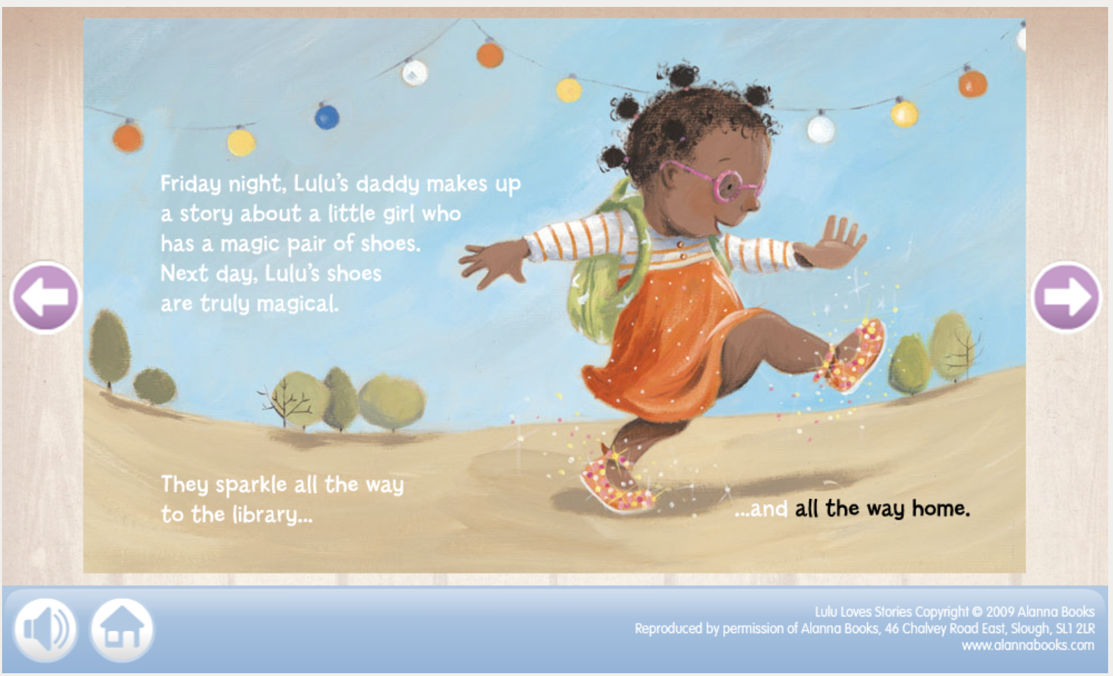

Figure 1: A pages from Lulu love stories showing activity of Lulu on Friday and next day.

# **4.0 Discussion**

*[Comment on the above, discussing your findings]*

*[评论以上，讨论你的发现]*

In this part what we evaluated in section 3.0, will be discussed against their own perspective (who make the website perspective), and perspective of others (Industry standard= UI best practice and UX principles).

在这一部分中，我们将从自己的角度(制作网站的人的角度)和其他人的角度(行业标准= UI最佳实践和UX原则)来讨论我们在3.0节中评估的内容。

You can make two paragraphs; first paragraph can discuss about one for UI and other for UX. Or You can make 7 points, each point discuss the UI and UX. In the example, I follow second way

你可以写两个段落;第一段可以讨论一个用于UI，另一个用于UX。或者你可以提出7个要点，每个要点讨论UI和UX。在本例中，我采用第二种方法

**UI discussion**

**Discusses how the eBook or story applies UI best Practices, and resembles or demonstrate use of design pattern. Clear and well considered**

**讨论电子书或故事如何应用UI最佳实践，以及类似或演示设计模式的使用。清晰且经过深思熟虑**

In this example, when I explain, I cared about their own and industry expects as highlighted

在这个例子中，当我解释的时候，我把自己的关心和行业期望作为重点

UI is compared to = programmer thinking when he make and industry best practices.

UI被比作程序员在制作和行业最佳实践时的思考。

**Student Example**

This example only explain one design element. You can use 7-10)

*Consistency*: in layouts, navigation, use of design patterns (for mobile and PC if known)

一致性:布局、导航、设计模式的使用(如果已知，适用于手机和PC)

**The websites aimed to design the UI feature consistency in layouts and navigation.**

**Are being carfully desined**

**Ease in navigation from 1 page to another, familer**

**It reflects that they keep consistent in UI Elements according to target audience**.

这些网站旨在设计UI在布局和导航方面的一致性。这反映了他们根据目标用户在UI元素上保持一致

**UX discussion**

**discusses in line with UX principles and concepts**

**根据用户体验原则和概念进行讨论**

UX is compared to = programmer thinking when he feels and industry UX principles.

UX被比作程序员感觉时的思考和行业UX原则。

**Moreover, the designer considers the feeling of young reader in the layout. It agree with UX principles, which suggest for visual consistency in fonts, colors, and image across different pages.**

此外，设计师在布局中考虑了年轻读者的感受。它符合UX原则，这些原则建议在不同页面上保持字体、颜色和图像的视觉一致性。

# **Conclusion 3**

* *10-15 words [****A summary of your evaluation,***
* ***20-30 words optional recommendations UI and UX***
* ***10 conclusion.***

**Example**

In this report, I evaluated Lulu love following UI practices and UX principle by focusing on various design elements, i.e., consistency, aesthics, Visual/Graphical elements, text, navigation, Input Controls, feedback, and background. It it suggested that the color combination and aesthics could be enhance with more dark colors combination with background. As dark combination often attracts the imagination in little minds as they learn the art of reading. This online inspired me and used most of design process in accordance with UI and UX industry standards.

在这份报告中，我通过关注不同的设计元素，即一致性、美学、视觉/图形元素、文本、导航、输入控制、反馈和背景，来评估Lulu是否遵循UI实践和UX原则。建议可以通过更多的深色与背景的搭配来加强色彩的搭配和美感。当小孩子学习阅读的艺术时，黑暗的组合常常会吸引他们的想象力。这个在线启发了我，并使用了大部分的设计过程，按照UI和UX行业标准。

# References

Optional to reference website(s) evaluated. Text in this section is not included in maximum word count of 600 words.

可选参考网站(s)评估。此部分的文本不包含在600字的最大字数中。

# Appendix

Include screen shots – essential if evaluating an application. Text in this section is not included in maximum word count of 600 words.

包括屏幕截图——在评估应用程序时必不可少。此部分的文本不包含在600字的最大字数中。